**Assignment No- 2**

1)Write a program that checks if a given year is a leap year or not using both if-else and switch-case.

1)USING IF-ELSE

import java.util.Scanner;

public class Ifelse {

public static void main(String[] args) {

Scanner scanner = new Scanner(System.in);

System.out.print("Enter a year: ");

int year = scanner.nextInt();

if (year % 4 == 0) {

if (year % 100 == 0) {

if (year % 400 == 0) {

System.out.println(year + " is a leap year.");

} else {

System.out.println(year + " is not a leap year.");

}

} else {

System.out.println(year + " is a leap year.");

}

} else {

System.out.println(year + " is not a leap year.");

}

scanner.close();

}

}

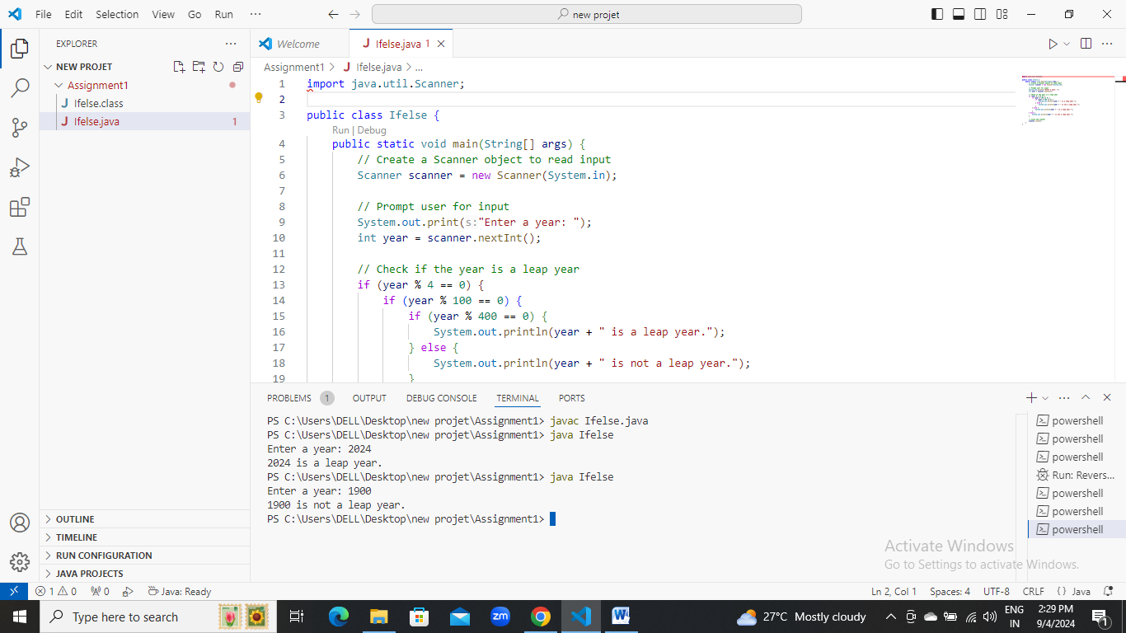

Using SWITCH-CASE

import java.util.Scanner;

class Leapyear{

public static void main(String[] args) {

Scanner scanner = new Scanner(System.in);

System.out.print("Enter a year: ");

int year = scanner.nextInt();

boolean isLeapYear = false;

switch (year % 4) {

case 0:

switch (year % 100) {

case 0:

switch (year % 400) {

case 0:

isLeapYear = true;

break;

default:

isLeapYear = false;

}

Break;

default:

isLeapYear = true;

}

break;

default:

isLeapYear = false;

}

if (isLeapYear) {

System.out.println(year + " is a leap year.");

} else {

System.out.println(year + " is not a leap year.");

}

scanner.close();

}

}

